Practical 2: Monte Carlo notes
In this practical, motivated by the use of Monte Carlo methods for option pricing in computational finance, we compute the average value of a “payoff” function based on independent “path” simulations.
The paths are two-dimensional and correspond to solutions of a 2D geometric Brownan motion SDE (stochastic differential equation):
dS₁ = r S₁ dt + σ S₁ dW₁
dS₂ = r S₂ dt + σ S₂ dW₂
in which dW₁ and dW₂ are increments of two correlated Brownian motions. The paths are approximated by an Euler-Maruyama discretisation to give
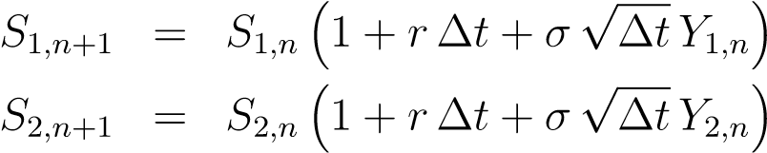
where ∆t is the timestep and Y_{1,n} and Y_{2,n} are Normal random variables, with zero mean and unit variance. They are independent of the values for other timesteps, but have correlation ρ which can be simulated by defining them as
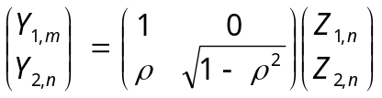
with Z_{1,n} and Z_{2,n} being independent Normal random variables with zero mean and unit variance.
With Monte Carlo simulation in computational finance, we simulate a large number of paths, using independent random numbers for each, and then average the financial “payoff” from each to estimate the expected value:
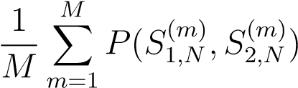
Note that using random numbers in a different order (as in Version 1 and Version 2 of the practical code) will result in different paths being simulated, and hence the computed averages will be slightly different. However, the statistics are still the same, so that in the limit of taking an infinite number of paths the averages from Version 1 and Version 2 would be identical.

